Code Pin assignment

<http://codepen.io/anon/pen/yYbEdb>

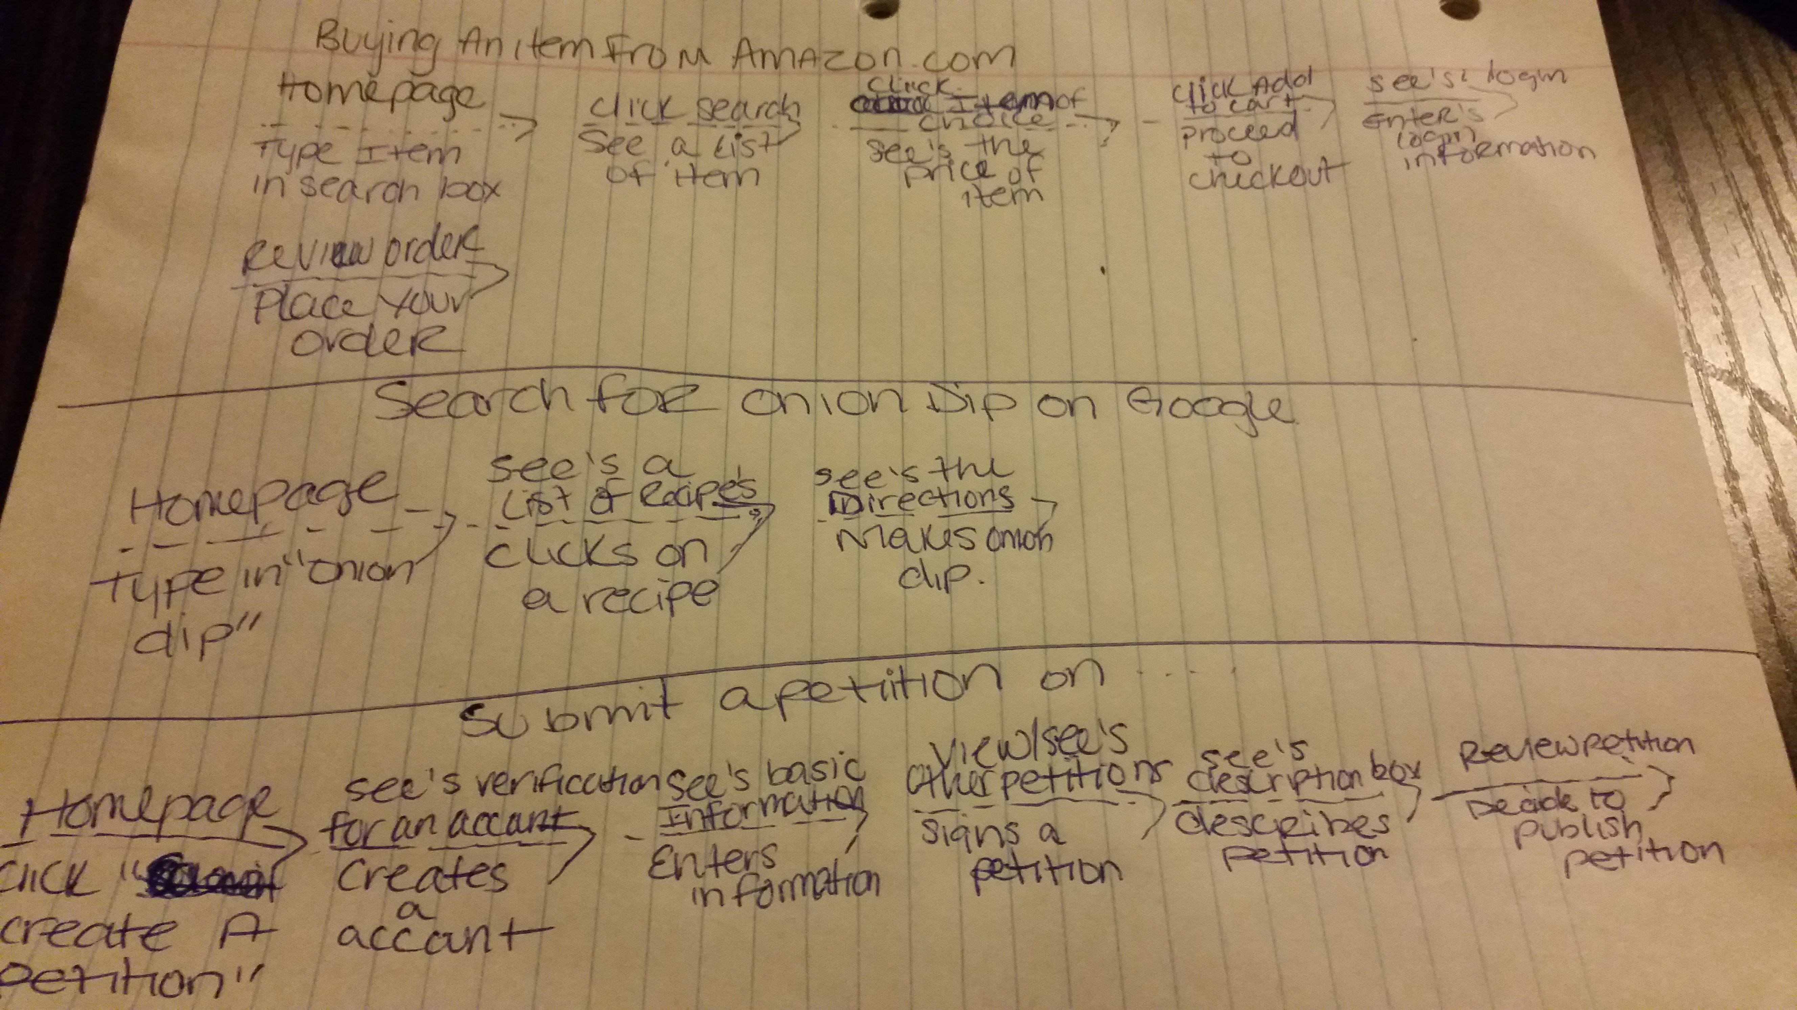

CARDS

[Jazz Bio]

[E-mail Sign-up list]

[dinner Recipes]

[Daily Inspirational message]

[fashion articles]

[cooking articles]

[inspirational articles]

[cooking videos]

[fashion videos]

[Inspirational videos]

[lunch recipes]

[Dessert recipes]

[Question post]

[Resources]

[Calendar of events]

Call to action:

-Signing up for e-mails to receive important information

-Sharing recipes with others to get exposure